**PTAX Enrolment Module for Tax Payer**

**First Step (Personal Details):**

**Individual:**

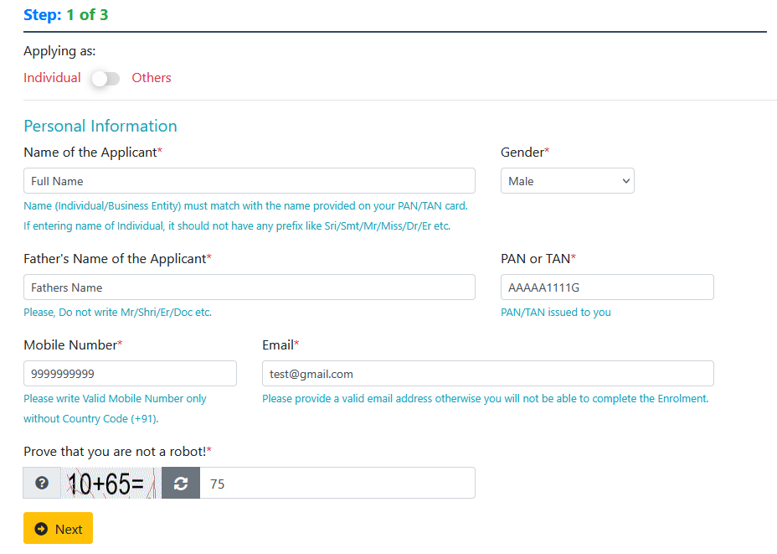

**Others:**

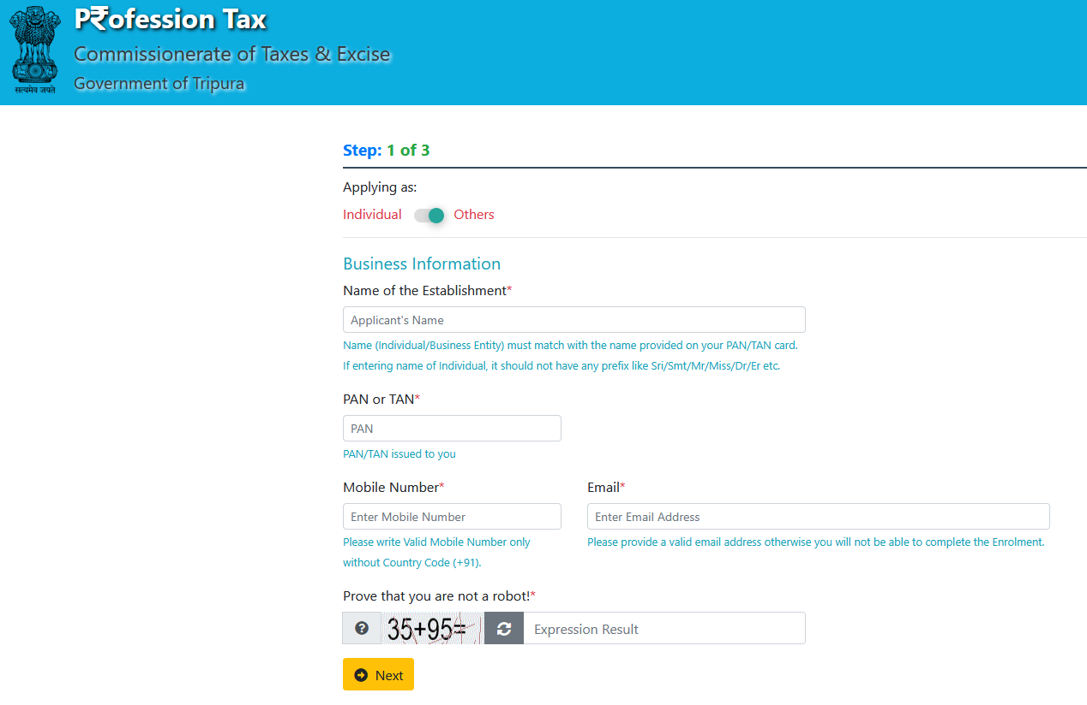

**Second Step (OTP Verification using Mobile Number):**

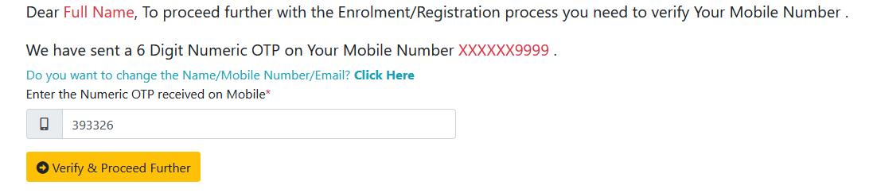

**Third Step (Establishment Information):**

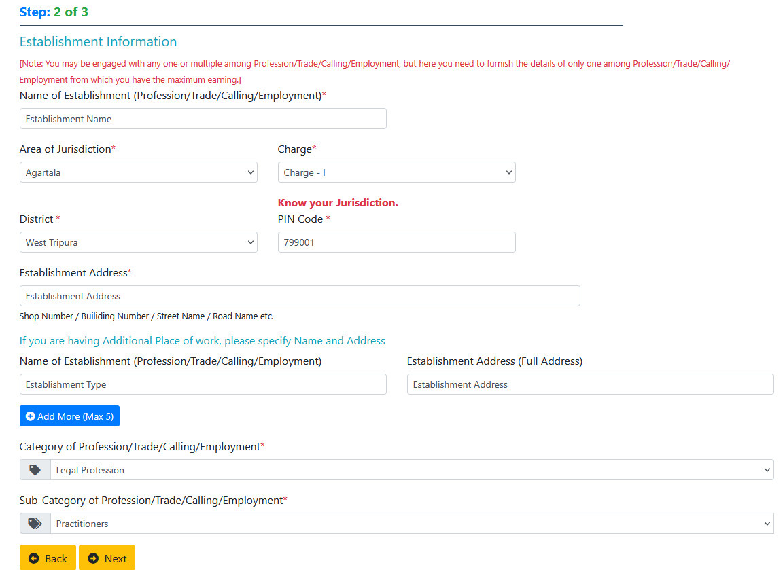

**Fourth Step (Chose Establishment Type):**



**Fifth Step (Profession):**

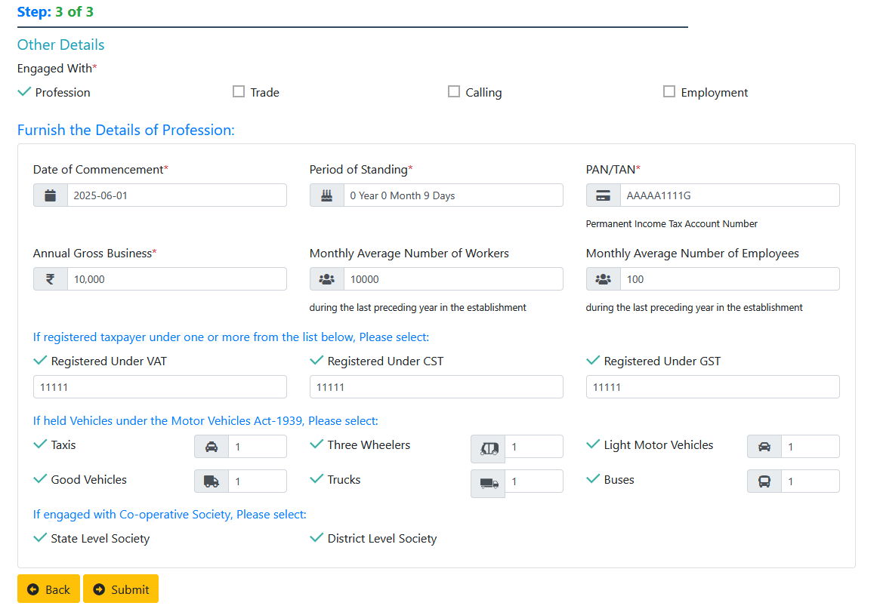

**Fifth Step (Trade):**

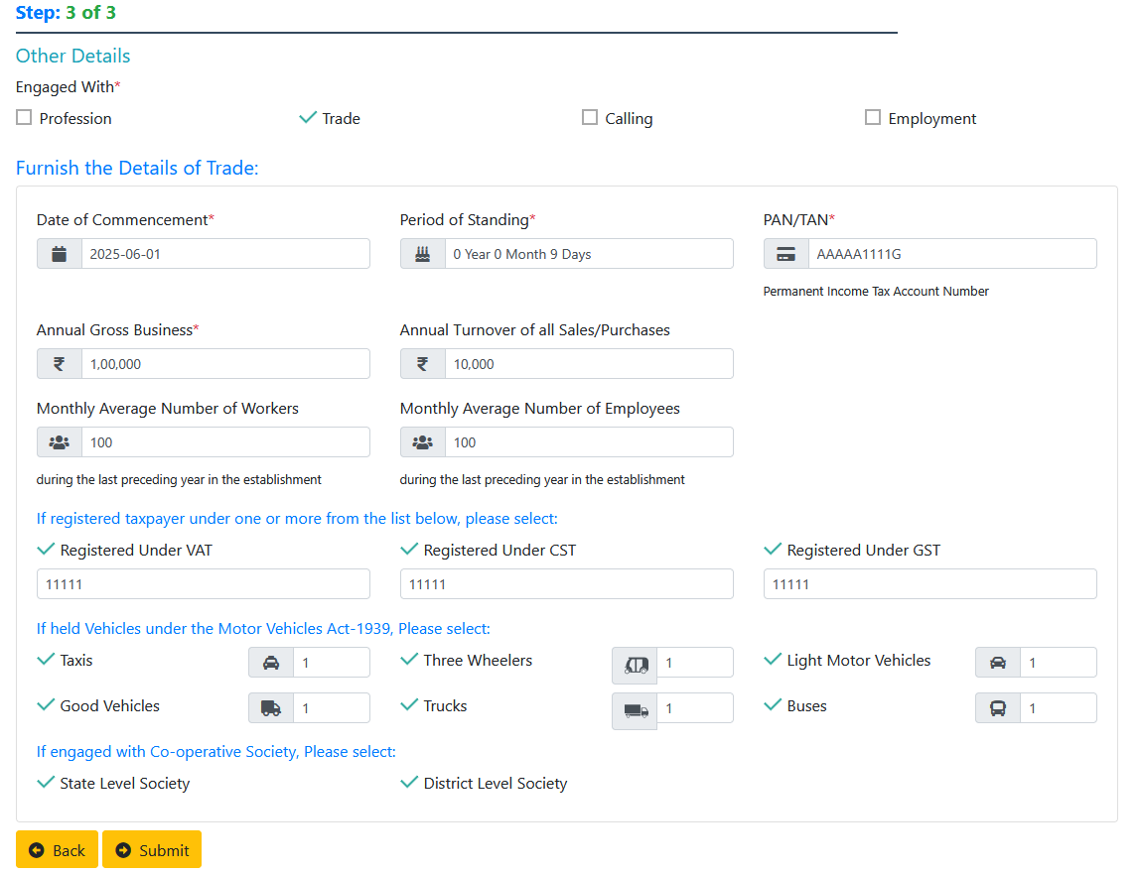

**Fifth Step (Calling):**

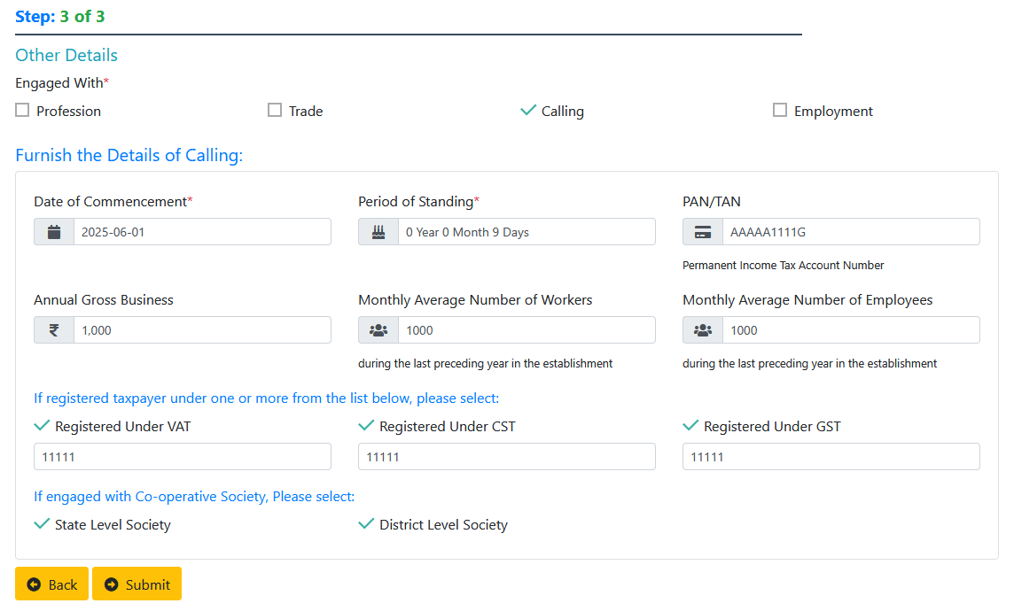

**Fifth Step (Employment):**

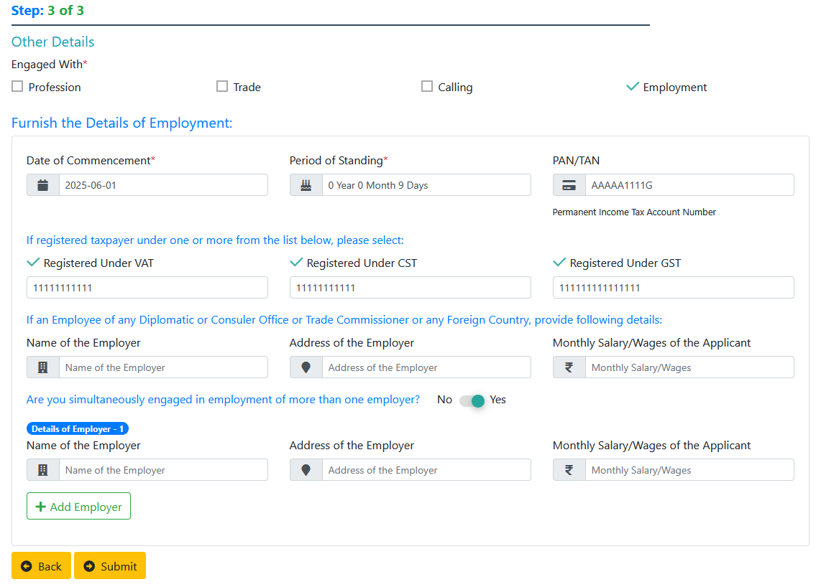

**Sixth Step (Check Details & Final Submit with Captcha):**

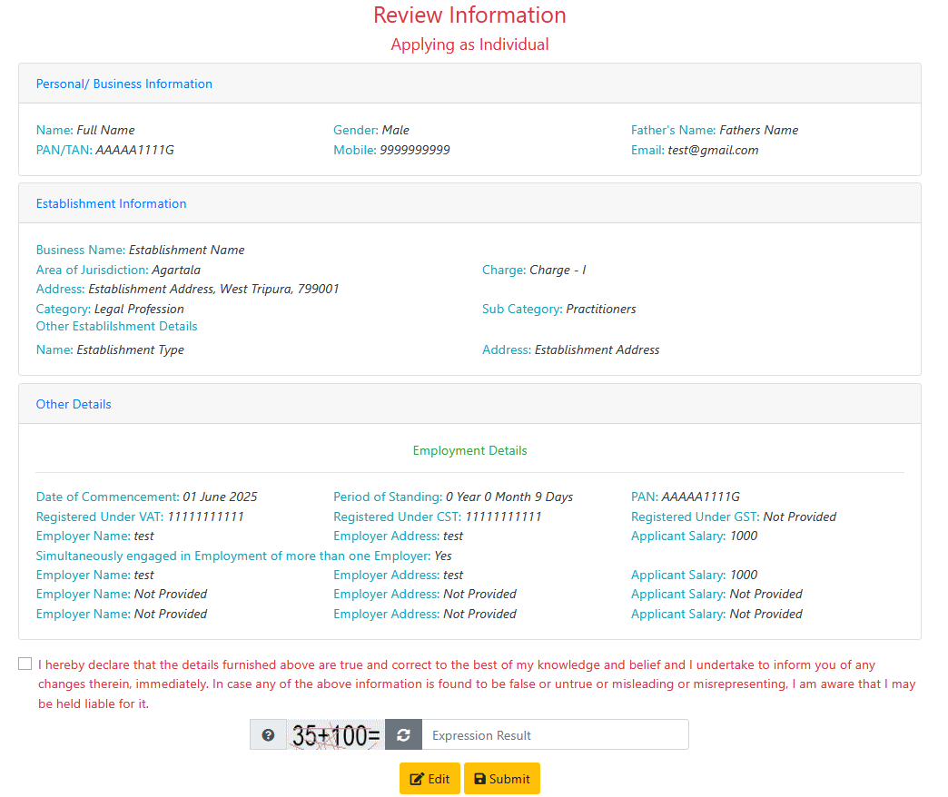

**Seventh Step (OTP Verification using Mobile Number):**

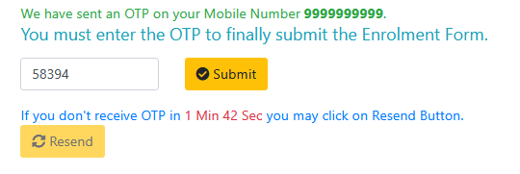

**Eight Step (Confirmation Message):**

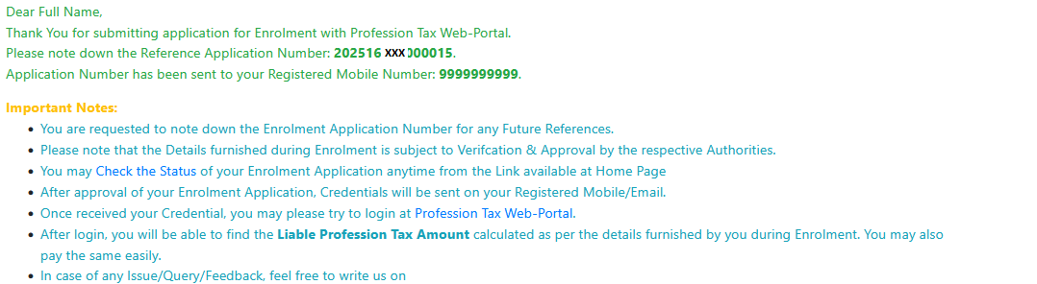

**Table Structure (Schema Name: ptax)**

**Temporary Table**

**Table 1: ttbl_temp_applicant_enrolment_details**

CREATE TABLE ptax.ttbl_temp_applicant_enrolment_details (

rsn BIGSERIAL PRIMARY KEY,

application_id VARCHAR(15),

ptan VARCHAR(10),

name VARCHAR(100),

gender CHAR(1),

father_name VARCHAR(100),

mobile CHAR(10),

email VARCHAR(100),

business_name VARCHAR(200),

jurisdiction_code VARCHAR(3),

charge_code VARCHAR(4),

address_text VARCHAR(100),

subdisctrict_lgd_code INTEGER,

district_lgd_code INTEGER,

pincode CHAR(6),

ptax_category INTEGER,

ptax_subcategory INTEGER,

engaged_with_profession BOOLEAN,

engaged_with_trade BOOLEAN,

engaged_with_calling BOOLEAN,

engaged_with_employement BOOLEAN,

pan CHAR(10),

inserted_on TIMESTAMP,

inserted_by VARCHAR(15),

inserted_from_ipv4 VARCHAR(15),

welcome_sms_count INTEGER,

welcome_email_count INTEGER,

establishment1_name VARCHAR(100),

establishment1_address VARCHAR(100),

establishment2_name VARCHAR(100),

establishment2_address VARCHAR(100),

establishment3_name VARCHAR(100),

establishment3_address VARCHAR(100),

establishment4_name VARCHAR(100),

establishment4_address VARCHAR(100),

establishment5_name VARCHAR(100),

establishment5_address VARCHAR(100),

applying_as_individual BOOLEAN,

status BOOLEAN,

doc_content BYTEA,

doc_content_trade BYTEA,

doc_content_death BYTEA,

doc_type CHAR(1),

cancellation_explanation VARCHAR(500)

);

**Table 2: ttbl_temp_applicant_employment_details**

CREATE TABLE ptax.ttbl_temp_applicant_employment_details (

rsn BIGSERIAL PRIMARY KEY,

application_id VARCHAR(15),

ptan VARCHAR(10),

commencement_date DATE,

period_of_standing VARCHAR(50),

pan CHAR(10),

vat_number VARCHAR(11),

cst_number VARCHAR(11),

gst_number VARCHAR(15),

employer_name VARCHAR(150),

employer_address VARCHAR(150),

monthly_salary NUMERIC(18, 2),

engaged_with_multiple_employer BOOLEAN,

employer_name1 VARCHAR(150),

employer_address1 VARCHAR(150),

monthly_salary1 NUMERIC(18, 2),

employer_name2 VARCHAR(150),

employer_address2 VARCHAR(150),

monthly_salary2 NUMERIC(18, 2),

employer_name3 VARCHAR(150),

employer_address3 VARCHAR(150),

monthly_salary3 NUMERIC(18, 2),

inserted_on TIMESTAMP,

inserted_by VARCHAR(50),

inserted_from_ipv4 VARCHAR(15),

updated_on TIMESTAMP,

updated_by VARCHAR(50),

updated_from_ipv4 VARCHAR(15),

status BOOLEAN

);

**Table 3: ttbl_temp_applicant_profession_details**

CREATE TABLE ptax.ttbl_temp_applicant_profession_details (

rsn BIGSERIAL PRIMARY KEY,

application_id VARCHAR(15),

ptan VARCHAR(12),

commencement_date DATE,

period_of_standing VARCHAR(50),

pan CHAR(10),

annual_gross_business NUMERIC(18, 2),

avg_workers_monthly INTEGER,

avg_employees_monthly INTEGER,

vat_number VARCHAR(11),

cst_number VARCHAR(11),

gst_number VARCHAR(15),

taxi_count INTEGER,

three_wheeler_count INTEGER,

lmv_count INTEGER,

good_vehicle_count INTEGER,

truck_count INTEGER,

bus_count INTEGER,

engaged_with_state_society BOOLEAN,

engaged_with_district_society BOOLEAN,

inserted_on TIMESTAMP,

inserted_by VARCHAR(50),

inserted_from_ipv4 VARCHAR(15),

updated_on TIMESTAMP,

updated_by VARCHAR(50),

updated_from_ipv4 VARCHAR(15),

status BOOLEAN

);

**Table 4: ttbl_temp_applicant_trade_details**

CREATE TABLE ptax.ttbl_temp_applicant_trade_details (

rsn BIGSERIAL PRIMARY KEY,

application_id VARCHAR(15),

ptan VARCHAR(10),

commencement_date DATE,

period_of_standing VARCHAR(50),

pan CHAR(10),

annual_gross_business NUMERIC(18, 2),

annual_turn_over NUMERIC(18, 2),

avg_workers_monthly INTEGER,

avg_employees_monthly INTEGER,

vat_number VARCHAR(11),

cst_number VARCHAR(11),

gst_number VARCHAR(15),

taxi_count INTEGER,

three_wheeler_count INTEGER,

lmv_count INTEGER,

good_vehicle_count INTEGER,

truck_count INTEGER,

bus_count INTEGER,

engaged_with_state_society BOOLEAN,

engaged_with_district_society BOOLEAN,

inserted_on TIMESTAMP,

inserted_by VARCHAR(50),

inserted_from_ipv4 VARCHAR(15),

updated_on TIMESTAMP,

updated_by VARCHAR(50),

updated_from_ipv4 VARCHAR(15),

status BOOLEAN

);

**Table 5: ttbl_temp_applicant_calling_details**

CREATE TABLE ptax.ttbl_temp_applicant_calling_details (

rsn BIGSERIAL PRIMARY KEY,

application_id VARCHAR(15),

ptan VARCHAR(10),

commencement_date DATE,

period_of_standing VARCHAR(50),

pan CHAR(10),

annual_gross_business NUMERIC(18, 2),

avg_workers_monthly INTEGER,

avg_employees_monthly INTEGER,

vat_number VARCHAR(11),

cst_number VARCHAR(11),

gst_number VARCHAR(15),

engaged_with_state_society BOOLEAN,

engaged_with_district_society BOOLEAN,

inserted_on TIMESTAMP,

inserted_by VARCHAR(50),

inserted_from_ipv4 VARCHAR(15),

updated_on TIMESTAMP,

updated_by VARCHAR(50),

updated_from_ipv4 VARCHAR(15),

status BOOLEAN

);

**Main Table**

**Table1: mtbl_users_taxpayers**

CREATE TABLE IF NOT EXISTS ptax.mtbl_users_taxpayers

(

rsn_mstbl_users bigserial,

userid character varying(15) COLLATE pg_catalog."default",

username character varying(100) COLLATE pg_catalog."default",

mobile character(10) COLLATE pg_catalog."default",

email character varying(100) COLLATE pg_catalog."default",

area_code character varying(3) COLLATE pg_catalog."default",

charge_code character varying(4) COLLATE pg_catalog."default",

userpassword character varying(64) COLLATE pg_catalog."default",

userroleid integer,

date_last_sucessfull_login timestamp without time zone,

date_last_failure_login timestamp without time zone,

count_failed_login_attempt integer NOT NULL,

is_locked boolean NOT NULL,

is_deleted boolean NOT NULL,

date_creation timestamp without time zone NOT NULL,

userid_createdby character varying(15) COLLATE pg_catalog."default",

created_from_ipv4 character varying(15) COLLATE pg_catalog."default",

date_modification timestamp without time zone,

userid_modifiedby character varying(15) COLLATE pg_catalog."default",

modified_from_ipv4 character varying(15) COLLATE pg_catalog."default",

date_deletion timestamp without time zone,

userid_deletedby character varying(15) COLLATE pg_catalog."default",

deleted_from_ipv4 character varying(15) COLLATE pg_catalog."default",

date_last_password_change timestamp without time zone,

remarks character varying(100) COLLATE pg_catalog."default",

deletion_remarks character varying(150) COLLATE pg_catalog."default",

updated_by character varying(15) COLLATE pg_catalog."default",

updated_on timestamp without time zone,

updated_from_ipv4 character varying(15) COLLATE pg_catalog."default",

updation_remarks character varying(150) COLLATE pg_catalog."default",

CONSTRAINT mtbl_users_taxpayers_pkey PRIMARY KEY (rsn_mstbl_users)

)

**Table2: ttbl_applicant_enrolment_details**

CREATE TABLE IF NOT EXISTS ptax.ttbl_applicant_enrolment_details

(

rsn bigserial,

application_id character varying(15) COLLATE pg_catalog."default",

ptan character varying(10) COLLATE pg_catalog."default",

name character varying(100) COLLATE pg_catalog."default",

gender character(1) COLLATE pg_catalog."default",

father_name character varying(100) COLLATE pg_catalog."default",

mobile character(10) COLLATE pg_catalog."default",

email character varying(100) COLLATE pg_catalog."default",

business_name character varying(200) COLLATE pg_catalog."default",

jurisdiction_code character varying(3) COLLATE pg_catalog."default",

charge_code character varying(4) COLLATE pg_catalog."default",

address_text character varying(100) COLLATE pg_catalog."default",

subdisctrict_lgd_code integer,

district_lgd_code integer,

pincode character(6) COLLATE pg_catalog."default",

ptax_category integer,

ptax_subcategory integer,

engaged_with_profession boolean,

engaged_with_trade boolean,

engaged_with_calling boolean,

engaged_with_employement boolean,

pan character(10) COLLATE pg_catalog."default",

inserted_on timestamp without time zone,

inserted_by character varying(15) COLLATE pg_catalog."default",

inserted_from_ipv4 character varying(15) COLLATE pg_catalog."default",

welcome_sms_count integer,

welcome_email_count integer,

establishment1_name character varying(100) COLLATE pg_catalog."default",

establishment1_address character varying(100) COLLATE pg_catalog."default",

establishment2_name character varying(100) COLLATE pg_catalog."default",

establishment2_address character varying(100) COLLATE pg_catalog."default",

establishment3_name character varying(100) COLLATE pg_catalog."default",

establishment3_address character varying(100) COLLATE pg_catalog."default",

establishment4_name character varying(100) COLLATE pg_catalog."default",

establishment4_address character varying(100) COLLATE pg_catalog."default",

establishment5_name character varying(100) COLLATE pg_catalog."default",

establishment5_address character varying(100) COLLATE pg_catalog."default",

applying_as_individual boolean,

CONSTRAINT ttbl_applicant_enrolment_details_pkey PRIMARY KEY (rsn)

)

**Table3: ttbl_applicant_profession_details**

CREATE TABLE IF NOT EXISTS ptax.ttbl_applicant_profession_details

(

rsn bigserial,

application_id character varying(15) COLLATE pg_catalog."default",

ptan character varying(12) COLLATE pg_catalog."default",

commencement_date date,

period_of_standing character varying(50) COLLATE pg_catalog."default",

pan character(10) COLLATE pg_catalog."default",

annual_gross_business numeric(18,2),

avg_workers_monthly integer,

avg_employees_monthly integer,

vat_number character varying(11) COLLATE pg_catalog."default",

cst_number character varying(11) COLLATE pg_catalog."default",

gst_number character varying(15) COLLATE pg_catalog."default",

taxi_count integer,

three_wheeler_count integer,

lmv_count integer,

good_vehicle_count integer,

truck_count integer,

bus_count integer,

engaged_with_state_society boolean,

engaged_with_district_society boolean,

inserted_on timestamp without time zone,

inserted_by character varying(50) COLLATE pg_catalog."default",

inserted_from_ipv4 character varying(15) COLLATE pg_catalog."default",

updated_on timestamp without time zone,

updated_by character varying(50) COLLATE pg_catalog."default",

updated_from_ipv4 character varying(15) COLLATE pg_catalog."default",

CONSTRAINT ttbl_applicant_profession_details_pkey PRIMARY KEY (rsn)

)

**Table4: ttbl_applicant_trade_details**

CREATE TABLE IF NOT EXISTS ptax.ttbl_applicant_trade_details

(

rsn bigserial,

application_id character varying(15) COLLATE pg_catalog."default",

ptan character varying(10) COLLATE pg_catalog."default",

commencement_date date,

period_of_standing character varying(50) COLLATE pg_catalog."default",

pan character(10) COLLATE pg_catalog."default",

annual_gross_business numeric(18,2),

annual_turn_over numeric(18,2),

avg_workers_monthly integer,

avg_employees_monthly integer,

vat_number character varying(11) COLLATE pg_catalog."default",

cst_number character varying(11) COLLATE pg_catalog."default",

gst_number character varying(15) COLLATE pg_catalog."default",

taxi_count integer,

three_wheeler_count integer,

lmv_count integer,

good_vehicle_count integer,

truck_count integer,

bus_count integer,

engaged_with_state_society boolean,

engaged_with_district_society boolean,

inserted_on timestamp without time zone,

inserted_by character varying(50) COLLATE pg_catalog."default",

inserted_from_ipv4 character varying(15) COLLATE pg_catalog."default",

updated_on timestamp without time zone,

updated_by character varying(50) COLLATE pg_catalog."default",

updated_from_ipv4 character varying(15) COLLATE pg_catalog."default",

CONSTRAINT ttbl_applicant_trade_details_pkey PRIMARY KEY (rsn)

)

**Table5: ttbl_applicant_calling_details**

CREATE TABLE IF NOT EXISTS ptax.ttbl_applicant_calling_details

(

rsn bigserial,

application_id character varying(15) COLLATE pg_catalog."default",

ptan character varying(10) COLLATE pg_catalog."default",

commencement_date date,

period_of_standing character varying(50) COLLATE pg_catalog."default",

pan character(10) COLLATE pg_catalog."default",

annual_gross_business numeric(18,2),

avg_workers_monthly integer,

avg_employees_monthly integer,

vat_number character varying(11) COLLATE pg_catalog."default",

cst_number character varying(11) COLLATE pg_catalog."default",

gst_number character varying(15) COLLATE pg_catalog."default",

engaged_with_state_society boolean,

engaged_with_district_society boolean,

inserted_on timestamp without time zone,

inserted_by character varying(50) COLLATE pg_catalog."default",

inserted_from_ipv4 character varying(15) COLLATE pg_catalog."default",

updated_on timestamp without time zone,

updated_by character varying(50) COLLATE pg_catalog."default",

updated_from_ipv4 character varying(15) COLLATE pg_catalog."default",

CONSTRAINT ttbl_applicant_calling_details_pkey PRIMARY KEY (rsn)

)

**Table6: ttbl_applicant_employment_details**

CREATE TABLE IF NOT EXISTS ptax.ttbl_applicant_employment_details

(

rsn bigserial,

application_id character varying(15) COLLATE pg_catalog."default",

ptan character varying(10) COLLATE pg_catalog."default",

commencement_date date,

period_of_standing character varying(50) COLLATE pg_catalog."default",

pan character(10) COLLATE pg_catalog."default",

vat_number character varying(11) COLLATE pg_catalog."default",

cst_number character varying(11) COLLATE pg_catalog."default",

gst_number character varying(15) COLLATE pg_catalog."default",

employer_name character varying(150) COLLATE pg_catalog."default",

employer_address character varying(150) COLLATE pg_catalog."default",

monthly_salary numeric(18,2),

engaged_with_multiple_employer boolean,

employer_name1 character varying(150) COLLATE pg_catalog."default",

employer_address1 character varying(150) COLLATE pg_catalog."default",

monthly_salary1 numeric(18,2),

employer_name2 character varying(150) COLLATE pg_catalog."default",

employer_address2 character varying(150) COLLATE pg_catalog."default",

monthly_salary2 numeric(18,2),

employer_name3 character varying(150) COLLATE pg_catalog."default",

employer_address3 character varying(150) COLLATE pg_catalog."default",

monthly_salary3 numeric(18,2),

inserted_on timestamp without time zone,

inserted_by character varying(50) COLLATE pg_catalog."default",

inserted_from_ipv4 character varying(15) COLLATE pg_catalog."default",

updated_on timestamp without time zone,

updated_by character varying(50) COLLATE pg_catalog."default",

updated_from_ipv4 character varying(15) COLLATE pg_catalog."default",

CONSTRAINT ttbl_applicant_employment_details_pkey PRIMARY KEY (rsn)

)

**Table7: ttbl_enrolment_application_status**

CREATE TABLE IF NOT EXISTS ptax.ttbl_enrolment_application_status

(

rsn bigserial,

application_id character varying(15) COLLATE pg_catalog."default",

ptan character varying(12) COLLATE pg_catalog."default",

is_viewed boolean,

viewed_on timestamp without time zone,

viewed_by character varying(15) COLLATE pg_catalog."default",

viewed_from_ipv4 character varying(15) COLLATE pg_catalog."default",

is_forwarded boolean,

forwarded_on timestamp without time zone,

forwarded_to character varying(15) COLLATE pg_catalog."default",

forwarded_by character varying(15) COLLATE pg_catalog."default",

forwarded_from_ipv4 character varying(15) COLLATE pg_catalog."default",

forwarding_remarks character varying(500) COLLATE pg_catalog."default",

is_inspected boolean,

inspected_on timestamp without time zone,

inspected_by character varying(15) COLLATE pg_catalog."default",

inspected_from_ipv4 character varying(15) COLLATE pg_catalog."default",

inspected_remarks character varying(500) COLLATE pg_catalog."default",

is_approved boolean,

approved_on timestamp without time zone,

approved_by character varying(15) COLLATE pg_catalog."default",

approved_from_ipv4 character varying(15) COLLATE pg_catalog."default",

approval_remarks character varying(500) COLLATE pg_catalog."default",

is_rejected boolean,

rejected_on timestamp without time zone,

rejected_by character varying(15) COLLATE pg_catalog."default",

rejected_from_ipv4 character varying(15) COLLATE pg_catalog."default",

rejection_remarks character varying(250) COLLATE pg_catalog."default",

CONSTRAINT ttbl_enrolment_application_status_pkey PRIMARY KEY (rsn)

)

**Master Table 1: mas_district**

CREATE TABLE IF NOT EXISTS ptax.mas_district

(

district_lgd_code integer NOT NULL,

district_name character varying(50) COLLATE pg_catalog."default" NOT NULL,

local_code integer,

CONSTRAINT mas_district_pkey PRIMARY KEY (district_lgd_code)

)

INSERT INTO ptax.mas_district (district_lgd_code, district_name, local_code) VALUES

(269, 'Dhalai', 4),

(270, 'North Tripura', 1),

(271, 'South Tripura', 3),

(272, 'West Tripura', 2),

(652, 'Khowai', 6),

(653, 'Sepahijala', 7),

(654, 'Gomati', 8),

(655, 'Unakoti', 5);

**Master Table 2: mtbl_area**

CREATE TABLE IF NOT EXISTS ptax.mtbl_area

(

code character(3) COLLATE pg_catalog."default",

name_en character varying(50) COLLATE pg_catalog."default",

name_bn character varying(100) COLLATE pg_catalog."default"

)

INSERT INTO ptax.mtbl_area (code, name_en, name_bn) VALUES

('AGT', 'Agartala', NULL),

('BSL', 'Bishalgarh', NULL),

('UDP', 'Udaipur', NULL),

('BLN', 'Belonia', NULL),

('TLM', 'Teliamura', NULL),

('AMB', 'Ambassa', NULL),

('KLS', 'Kailasahar', NULL),

('DMN', 'Dharmanagar', NULL);

**Master Table 3: mtbl_charge**

CREATE TABLE IF NOT EXISTS ptax.mtbl_charge

(

code character varying(4) COLLATE pg_catalog."default",

charge character varying(255) COLLATE pg_catalog."default",

area_code character(3) COLLATE pg_catalog."default",

charge_sn integer

)

INSERT INTO ptax.mtbl_charge (code, charge, area_code, charge_sn) VALUES

('AMBA', 'Ambassa', 'AMB', 1),

('BELO', 'Belonia', 'BLN', 2),

('BISH', 'Bishalgarh', 'BSL', 3),

('CH01', 'Charge - I', 'AGT', 4),

('CH02', 'Charge - II', 'AGT', 5),

('CH03', 'Charge - III', 'AGT', 6),

('CH04', 'Charge - IV', 'AGT', 7),

('CH05', 'Charge - V', 'AGT', 8),

('CH06', 'Charge - VI', 'AGT', 9),

('CH07', 'Charge - VII', 'AGT', 10),

('CH08', 'Charge - VIII', 'AGT', 11),

('DHAR', 'Dharmanagar', 'DMN', 12),

('KAIL', 'Kailashahar', 'KLS', 13),

('TELI', 'Teliamura', 'TLM', 14),

('UDAI', 'Udaipur', 'UDP', 15);

**Master Table 4: mtbl_role**

CREATE TABLE IF NOT EXISTS ptax.mtbl_role

(

role_id integer NOT NULL,

designation_code character varying(10) COLLATE pg_catalog."default",

role_name character varying(25) COLLATE pg_catalog."default",

role_name_ll character varying(50) COLLATE pg_catalog."default",

outside_visibility boolean,

CONSTRAINT mtbl_role_pkey PRIMARY KEY (role_id)

)

INSERT INTO ptax.mtbl_role (role_id, designation_code, role_name, role_name_ll, outside_visibility) VALUES

(1, 'ADMIN', 'Website Administrator', NULL, NULL),

(2, 'COMTAX', 'Commissioner of Taxes', NULL, NULL),

(3, 'SUPTAX', 'Supritendent of Taxes', NULL, NULL),

(4, 'INSTAX', 'Inspector of Taxes', NULL, NULL),

(5, 'SCA', 'Senior Computer Assistant', NULL, NULL),

(6, 'CLERK', 'Clerk', NULL, NULL),

(7, 'ENRLUSER', 'Enroled Tax Payer', NULL, NULL),

(8, 'REGUSER', 'Registered Tax Payer', NULL, NULL);

**Master Table 5: mtbl_ptax_category**

CREATE TABLE IF NOT EXISTS ptax.mtbl_ptax_category

(

cat_rsn bigserial,

cat_id integer,

cat_description character varying(150) COLLATE pg_catalog."default",

CONSTRAINT mtbl_ptax_category_pkey PRIMARY KEY (cat_rsn)

)

INSERT INTO ptax.mtbl_ptax_category (cat_rsn, cat_id, cat_description) VALUES

(1, 1, 'Legal Profession'),

(2, 2, 'Medical Profession'),

(3, 3, 'Consultants'),

(4, 4, 'Engineering Profession'),

(5, 5, 'Technicians'),

(6, 6, 'Agents'),

(7, 7, 'Service Providers'),

(8, 8, 'Contractors or Suppliers (Annual Gross Turnover more than 5 Lakhs)'),

(9, 9, 'Directors'),

(10, 10, 'Employers or Establishment'),

(11, 11, 'Dealer, Person, Tax Payer, Traders (Annual Gross Turnover more than 3 Lakhs)'),

(12, 12, 'Agents and Distributors'),

(13, 13, 'Licenced Vendor'),

(14, 14, 'Owners or Leasees or Licencees or Occupiers'),

(15, 15, 'Societies'),

(16, 16, 'Companies'),

(17, 17, 'Partnership Firms'),

(18, 18, 'Holders of Permits of Transport Vehicle granted under MVI Act. 1939 or 1988 which are issued or adopted to be used for hire or reward for'),

(19, 19, 'Individuals or Institutions'),

(20, 20, 'Persons other than those mentioned in any of the preceding entries.'),

(21, 21, 'Salary & Wage Earner');

**Master Table 6: mtbl_ptax_category_subcategory**

CREATE TABLE IF NOT EXISTS ptax.mtbl_ptax_category_subcategory

(

record_rsn bigserial,

cat_code integer,

cat_description character varying(150) COLLATE pg_catalog."default",

subcat_code integer,

subcat_description character varying(150) COLLATE pg_catalog."default",

is_visible integer,

CONSTRAINT mtbl_ptax_category_subcategory_pkey PRIMARY KEY (record_rsn)

)

INSERT INTO ptax.mtbl_ptax_category_subcategory (

record_rsn, cat_code, cat_description, subcat_code, subcat_description, is_visible

) VALUES

(1, 1, 'Legal Profession', 1, 'Practitioners', 1),

(2, 1, 'Legal Profession', 2, 'Solicitors', 1),

(3, 1, 'Legal Profession', 3, 'Notaries Public', 1),

(4, 1, 'Legal Profession', 4, 'Others', 1),

(5, 2, 'Medical Profession', 1, 'Dentists', 1),

(6, 2, 'Medical Profession', 2, 'Pathologists', 1),

(7, 2, 'Medical Profession', 3, 'Cardiologist', 1),

(8, 2, 'Medical Profession', 4, 'Dermatologist', 1),

(9, 2, 'Medical Profession', 5, 'Endocrinologist', 1),

(10, 2, 'Medical Profession', 6, 'Epidemiologist', 1),

(11, 2, 'Medical Profession', 7, 'Gynecologist', 1),

(12, 2, 'Medical Profession', 8, 'Neurologist', 1),

(13, 2, 'Medical Profession', 9, 'Neurosurgeon', 1),

(14, 2, 'Medical Profession', 10, 'Obstetrician', 1),

(15, 2, 'Medical Profession', 11, 'Orthopedic Surgeon', 1),

(16, 2, 'Medical Profession', 12, 'ENT Specialist', 1),

(17, 2, 'Medical Profession', 13, 'Pediatrician', 1),

(18, 2, 'Medical Profession', 14, 'Physiologist', 1),

(19, 2, 'Medical Profession', 15, 'Plastic Surgeon', 1),

(20, 2, 'Medical Profession', 16, 'Psychiatrist', 1),

(21, 2, 'Medical Profession', 17, 'Radiologist', 1),

(22, 2, 'Medical Profession', 18, 'Urologist', 1),

(23, 2, 'Medical Profession', 19, 'Surgeon', 1),

(24, 2, 'Medical Profession', 20, 'Oncologist', 1),

(25, 2, 'Medical Profession', 21, 'Paramedical', 1),

(26, 2, 'Medical Profession', 22, 'Others', 1),

(27, 3, 'Consultants', 1, 'Medical Consultants', 1),

(28, 3, 'Consultants', 2, 'Management Consultants', 1),

(29, 3, 'Consultants', 3, 'R.C.C. Consultants', 1),

(30, 3, 'Consultants', 4, 'Software Consultant', 1),

(31, 3, 'Consultants', 5, 'Chartered Accountant', 1),

(32, 3, 'Consultants', 6, 'Cost Accountants', 1),

(33, 3, 'Consultants', 7, 'Actuaries', 1),

(34, 3, 'Consultants', 8, 'Market Research Analyst', 1),

(35, 3, 'Consultants', 9, 'Other Consultants', 1),

(36, 4, 'Engineering Profession', 1, 'Mechanical Engineer', 1),

(37, 4, 'Engineering Profession', 2, 'Chemical Engineer', 1),

(38, 4, 'Engineering Profession', 3, 'Software Engineer', 1),

(39, 4, 'Engineering Profession', 4, 'Civil Engineer', 1),

(40, 4, 'Engineering Profession', 5, 'Electrical Engineer', 1),

(41, 4, 'Engineering Profession', 6, 'Electronics Engineer', 1),

(42, 4, 'Engineering Profession', 7, 'Telcom Engineer', 1),

(43, 4, 'Engineering Profession', 8, 'Architects', 1),

(44, 4, 'Engineering Profession', 9, 'Other Engineers', 1);